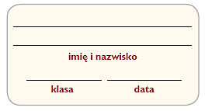

**W Amazonii**

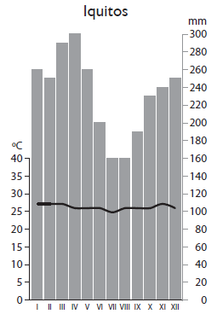

**1.** Na podstawie klimatogramu podaj trzy cechy klimatu Amazonii.

a) _________________________________________________________________

_________________________________________________________________

b) _________________________________________________________________

_________________________________________________________________

c) _________________________________________________________________

_________________________________________________________________

**2.** Podaj objaśnienia terminów użytych w logogryfie. Następnie wyjaśnij znaczenie otrzymanego hasła.

|  |  |  |  |  |  |  |  |  |  |  |  |  |  |  |  |  |
| --- | --- | --- | --- | --- | --- | --- | --- | --- | --- | --- | --- | --- | --- | --- | --- | --- |
| **C** | **H** | **I** | **N** | **I** | **N** | **A** |  | | | | | | | | | |
|  | | | | | | **M** | **A** | **H** | **O** | **N** | **I** | **W** | **I** | **E** | **C** |  |
| **J** | **A** | **G** | **U** | **A** | **R** |
| **K** | **A** | **U** | **C** | **Z** | **U** | **K** |
| **H** | **E** | **L** | **I** | **K** | **O** | **N** | **I** | **A** |
| **G** | **R** | **E** | **E** | **N** | **P** | **E** | **A** | **C** | **E** |
| **E** | **P** | **I** | **F** | **I** | **T** |  | | | | | | |
| **I** | **N** | **D** | **I** | **A** | **N** | **I** | **E** |

1. _________________________________________________________________________________________________________

2. _________________________________________________________________________________________________________

3. _________________________________________________________________________________________________________

4._________________________________________________________________________________________________________

5._________________________________________________________________________________________________________

6._________________________________________________________________________________________________________

7._________________________________________________________________________________________________________

8._________________________________________________________________________________________________________

Hasło: _______________________________ ‒ ______________________________________________________________________

**3.** Korzystając z dostępnych źródeł, przeanalizuj problem nadmiernej wycinki wilgotnych lasów równikowych w Amazonii i zapisz propozycje jego rozwiązania w postaci metaplanu.

|  |  |
| --- | --- |
| **Problem: Nadmierna wycinka lasów Amazonii** | |
| ***Jak jest?*** | ***Jak powinno być?*** |
|  |  |
| ***Dlaczego nie jest tak, jak powinno być?*** | |
|  | |
| ***Wnioski – propozycje rozwiązania problemu*** | |
|  | |